Postgraduate Education
(HWNZ) Application
2023
Instructions

- This application must be completed in its entirety. Incomplete forms will not be accepted.
- This application must be saved and submitted as an attachment with any additional documentation - paper or scanned applications will not be accepted.
- Please read the 2023 HWNZ Information resource on website. Also see HWNZ Postgraduate Nursing Training Specification for background information at https://www.health.govt.nz/our-work/health-workforce/investment-and-purchasing#nursing
- This application covers the entire 2023 academic year (semesters 1 & 2) and is your ONLY opportunity to apply for funding
- Organisational support must be obtained in order to access this funding
- All applicants will be advised of the outcome via email as soon as possible
- Enrolment with the Tertiary Education provider is a separate process and is the responsibility of the applicant.
Applications close Sunday 4 November 2022

For questions please contact:
Roger Huntington
Associate Director of Nursing
Nursing Services, Te Whatu Ora - Tairāwhiti
06 869 0500 ext. 8963
Email roger.huntington@tdh.org.nz

Section A. Applicant Information
Surname  Must match APC |  | First Name  Must match APC
NZNC APC Number |  | Gender | Choose an item.
Date of Birth | Click or tap to enter a date. | Employee Number
Phone |  | Work Phone
Email |  | Ethnicity | Choose an item.
NZ Citizen/Perm Resident Status | Choose an item. | Iwi
Section B: Employment Information
Name of Employer
Role Title
Direct Line Manager
Current FTE | Choose an item.
Length in current role
Do you expect to have the same FTE in 2022?  If no, please indicate | Choose an item.  Choose an item.
Current PDRP Level | Choose an item.
DHB Employees
Clinical Care Group | Choose an item.
Clinical Area of Practice/Specialty | Choose an item.
Non- DHB Employees
PHO, Aged Residential Care, Plunket, Ministry of Health Contract Providers
Clinical Area of Practice/Specialty | Choose an item.
Full Postal Address

Section C: Postgraduate Qualification Level
Please indicate qualification level you intend to work toward in 2022 – see illustration below | Choose an item.
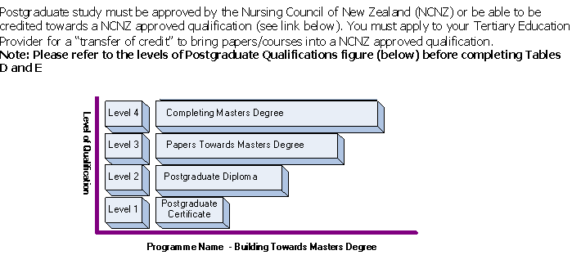

Section D: Completed Qualification Level
List completed papers within each qualification level that builds towards your intended qualification
Qualification | Name of Paper | Credit | Grade
Postgraduate Certificate
Level 1
Postgraduate Diploma
Level 2
Postgraduate Masters
Level 3
Postgraduate Masters
(Usually final 2 papers)

Section E: Proposed Enrolment
List papers you wish to enrol in for 2023 ( all semesters)
Paper Code | Paper Name | Semester | Credit |  | Start Date | Completion Date | Tertiary Provider i.e. EIT, AUT
MN8.402 | Advanced Pathophysiology for Health Professionals | 1 | 30 |  | 17/02/2023 | 26/06/202e | EIT
 |  |  |  |  | Click or tap to enter a date. | Click or tap to enter a date.
 |  |  |  |  | Click or tap to enter a date. | Click or tap to enter a date.
 |  |  |  |  | Click or tap to enter a date. | Click or tap to enter a date.
Will you complete your qualification in 2022? |  |  |  | Choose an item.

Section F: Post Masters
Name of completed Master’s Degree
University
Year Conferred

Section G: Career Plan
Part 1- Knowing Yourself: The first step in planning your career is evaluating and understanding your aspirations; strengths; interests; drivers and other influences. Please outline below.
Part 2- Explore Possibilities: Research the development possibilities and career pathways that are open and attractive to you. Consider your self-assessment outcomes and future health workforce needs.
Part 3- Making choices: Consider the suitability of your options and decide (with the assistance of the person you report to) if this is the best match to your aspirations and workforce needs
Part 4- Make it happen: In order to achieve your goals you need to have an agreed course of action. You and your manager need to have a clear understanding of what steps you will be taking, the commitment needed by both you and your manager and relevant timeframes. You are now ready to detail who has to do what to make things happen.

Section H: Travel
Indicate the number of study days there will be. Must be discussed with manager
~ Online papers attract an allocation of 4 study days.
Number of trips
Mode of transportation | Choose an item.
Clinical Release PHC/NGO/ARC Trainees only (conditions apply)  ~Clinical release costs (per hour) of releasing the trainee while the trainee attends the formal aspects of their training programme, including academic and clinical mentoring during the trainees working hours. | Choose an item.

Section I: Applicant Consent
- I confirm that all the information supplied in support of my application is accurate at the date of signing and the supporting documentation is enclosed
- I consent to the disclosure of the personal information given on this form to recipients for purposes related to the advancement of my studies and as required by protocols between Hauora Tairāwhiti and external agencies
- I understand that as per the Te Whatu Ora Tairāwhiti Bond agreement, which will be sent to me, if I withdraw from study I may need to repay funds allocated to me
- I authorise and direct any Tertiary Education provider at which I am/have been undertaking any course of study relating to this grant to provide to Te Whatu Ora Tairāwhiti and Health Workforce New Zealand the following information:
• Full name
• Relevant course completion information
• Date of course completion
• Outcome of course
• Pass or failure to attain a pass
• Withdrawal from course
• Date and reason for withdrawal
Applicants eSignature & Date

Section J: Managers Endorsement
This section is for managers to complete.
Your responsibility as manager is:
- To ensure you review this application with your employee & understand what supporting this application will entail
- That the application is completed in full
- That this form must be submitted by you to education@tdh.org.nz which provides your endorsement

For DHB staff:  Has your employee completed all Mandatory Training?  If no, please outline a plan to ensure training will be met by commencement of 2023 studies | Choose an item.
Managers eSignature & Date | Click or tap to enter a date.
** Incomplete or applications sent directly from applicant will not be accepted **
Receipt of application will be emailed to applicant

